White Paper

Implementing SAP® BusinessObjects™ 4.0 with Greenplum Database

Planning, Implementation, Configuration and Best Practices

Abstract

This paper outlines recommendations for SAP® BusinessObjects™ 4.0 with the Greenplum Database. It is designed to help customers and field personnel implement SAP Business Objects in a Greenplum database environment.

October 2012

Copyright © 2012 EMC Corporation. All Rights Reserved.

EMC believes the information in this publication is accurate of its publication date. The information is subject to change without notice.

The information in this publication is provided “as is”. EMC Corporation makes no representations or warranties of any kind with respect to the information in this publication, and specifically disclaims implied warranties of merchantability or fitness for a particular purpose.

Use, copying, and distribution of any EMC software described in this publication requires an applicable software license.

For the most up-to-date listing of EMC product names, see EMC Corporation Trademarks on EMC.com.

Part Number hxxxxx

Table of Contents

Executive Summary 4

Audience 4

Scope 4

Greenplum Database Overview 5

EMC Greenplum Data Computing Appliance 5

EMC Greenplum Data Integration Accelerator 6

Overview of SAP Business Objects 7

Installation and Configuration Process 8

Download the SAP® BusinessObjects™ server software 8

Obtaining a BusinessObjects™ software license 10

Download the SAP® BusinessObjects™ client tools 11

Identify the appropriate ODBC driver on Powerlink 13

Download the identified ODBC driver from Subscribenet 18

Install the pre-requisite SAP® BusinessObjects™ application host software 21

Install the BusinessObjects™ software 21

Install the ODBC driver 23

Validate the ODBC driver 26

Solution Testing 30

Creating a new 32-bit ODBC connection to Greenplum 30

Starting the Information Design Tool 30

Universe Design Tool 43

Web Rich Client 55

Performance Tuning 60

Best Practices 70

Conclusion 71

References 72

# Executive Summary

The Greenplum Database is a high performance analytics platform based on a shared-nothing MPP (Massively Parallel Processing) architecture. Greenplum Database facilitates Business Intelligence and Data Analytics using commodity hardware. The database integrates with a wide variety of 3rd party vendor software products including solutions for Data Integration, Business Intelligence, Data Modeling and Data Analytics.

BusinessObjects™ BI 4.0 is the latest release of SAP® business intelligence software. It provides customers the ability to make business decisions through self-service access to data analysis. The software is designed to help organizations make better business decisions.

The purpose of this paper is to describe the process needed to successfully implement SAP® BusinessObjects™ in a Greenplum environment. It provides a step-by-step outline to successfully design, implement, and configure SAP® BusinessObjects™ with Greenplum. It also describes some basic best practices for testing the solution and ensuring success in a production system.

## Audience

This white paper is intended for EMC field facing personnel including technical consultants, solution architects, and support engineers, as well as customers who are considering integration of SAP Business Objects in a Greenplum database environment.

## Scope

This document provides an overview of the steps needed to complete a successful implementation of the SAP® BusinessObjects™ software in a GPDB environment. It includes the basic steps needed to install the Business Objects software, the steps needed to install, configure, and validate connectivity to the Greenplum database via a supported data driver, and perform basic interoperability testing of the Greenplum/SAP Business Objects solution. It also provides some best practices for the solution. This guide does not provide information on installing the Greenplum Database – this information can be found in the Greenplum Database Installation Guide found on EMC Powerlink. More detailed information on the installation of Business Objects can be found in the references found at the end of this document. The examples used in this document are provided to give the reader a high-level understanding of Business Objects functionality in a Greenplum environment.

# Greenplum Database Overview

The Greenplum Database design is based on a share-nothing MPP (Massively Parallel Processing) architecture which facilitates Business Intelligence and analytical processing using commodity hardware. Data is distributed across multiple segment servers in the Greenplum Database to achieve no disk-level sharing. The segment servers are able to process queries in a parallel manner in order to promote the highest degree of parallelism and scalability.

Highlights of the Greenplum Database include:

* Dynamic Query Prioritization which provides continuous real-time balancing of the resources across queries
* Self-Healing Fault Tolerance which provides intelligent fault detection and fast online differential recovery
* Polymorphic Data Storage and Multi-storage/SSD Support which includes tunable compression and support for both row-and column-oriented storage
* Analytics and Language Support which supports analytical functions for advanced in-database analytics
* Health Monitoring and Alerting, which provide integrated email and SNMP notification for advanced support capabilities.

## EMC Greenplum Data Computing Appliance

EMC’s Greenplum Data Computing Appliance (DCA) is a purpose-build, massively parallel processing (MPP) data warehousing appliance that is created to integrate storage, database, and networking into a single enterprise-class system based on the Greenplum Database. It is built to deliver the industry’s fastest data loading speed, and can linearly expand to accommodate customers’ storage requirements for Big Data. It takes advantage of large clusters of increasingly powerful, commodity servers, storage and network switches to minimize the customers’ cost of ownership. The database software is Greenplum Database, a “shared-nothing” architecture that is optimized for fast queries and data loading, for fastest operations with the maximum degree of parallelism possible. The DCA integrates Greenplum Database, data loading and Hadoop software with compute, storage and network components, delivered racked and ready for immediate data loading and query execution.

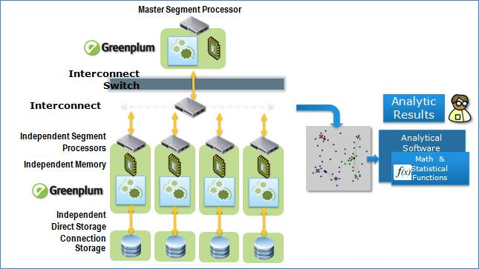

## EMC Greenplum Data Integration Accelerator

The Data Integration Accelerator (DIA) is specially built to facilitate fast data loading to the DCA. It integrates the Greenplum data loading software called gpfdist with the server, storage and networking gear into a single system. It leverages the high-speed internal communication network to deliver the data quickly to the DCA.

Each server in the DIA is preloaded with RedHat Enterprise Linux operating systems. These RedHat Linux hosts are intended to be configured and have the requisite software stacks installed so they can serve as a ‘near the DCA’ platform for data integration software.

The DIA comes in blocks of 4 servers. Each block is referred to as a module; up to 4 modules of DIA can be ordered in each rack. With each server, the Greenplum gpfdist utility is pre-loaded by default; this utility provides parallel file distribution server utility software that is used with read-only external tables for fast, parallel data loading of text files into a Greenplum database.

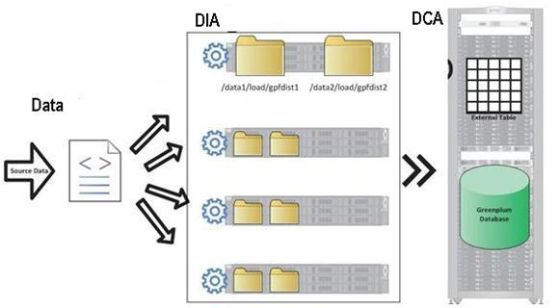

# Overview of SAP Business Objects

In today’s fast-moving organizations, business intelligence is essential for consistent execution of strategy by top management, improving customer loyalty, increasing forecast accuracy, and measuring profitability. Thus a BI platform must provide an enterprise-wide information infrastructure that allows an organization to make every person, process, and decision more intelligent – and closes the loop between information and action.

SAP® BusinessObjects™ business intelligence (BI) solutions help organizations better understand their business and make more confident decisions.

Business Objects supports the creation of a universe that separates business representation of organization or department data without burdening users with the underlying technical details. Universe creation is intuitive, easy and separates business logic. Meta Data modeler is empowered with advanced database features and SQL support that is integrated with Business Objects components.

There are 4 tiers in SAP® BusinessObjects™ BI 4.0:

* 1. Reporting or client tier – This is the client tool that connects to the BusinessObjects™ server.
  2. BusinessObjects™ server – this is the main component of the product that consists of the relational connection, the data foundation (directly related to Greenplum tables), and the business layer (where measures, which allow aggregate functions such as sum and average and dimensions are defined against the underlying fields from Greenplum tables; measures allow us to perform aggregate functions such as sum and average).
  3. Connectivity layer – The ODBC 32-bit driver is used for client tools connecting to BusinessObjects™. Note: the Data Direct driver is generally recommended but there are cases in which the Postgres open source driver is also used.
  4. Greenplum Database – either the Greenplum Database versions 4.1.x or 4.2.x are supported. Specific information on supported versions can be found in the Greenplum Support Matrix in the eLab Navigator on Powerlink.

SAP® has made a number of naming changes for the client tools available in BusinessObjects™ between version 3.1 and 4.0. The following includes these naming changes:

1. Business Objects Enterprise (3.0) Business Objects Business Intelligence Platform
2. Infoview BI Launch Pad
3. Business Objects Xcelsius Platform SAP Business Objects Dashboard Design
4. Universe Design Information Design Tools & Universe Design Tool
5. Crystal Reports 2008 Crystal Reports for Entpr., Crystal Reports 2011
6. Business Objects Voyager Business Objects Analysis, Edition for OLAP
7. Dashboard Builder BI Workspaces
8. Web Intelligence SAP Business Objects Interactive Analysis
9. Translation Manager Translation Management Tool

# Installation and Configuration Process

Installation and configuration of SAP® BusinessObjects™ with Greenplum Database requires the following high-level steps:

1. Download the SAP® BusinessObjects™ server software and documentation
2. Obtain a BusinessObjects™ software license from SAP
3. Download the SAP® BusinessObjects™ client tools
4. Identify the appropriate ODBC driver (Data Direct or Postgres) on Powerlink
5. Download the identified ODBC driver from Subscribenet
6. Install the pre-requisite software BusinessObjects™ application host
7. Install the BusinessObjects™ software
8. Install the ODBC driver

The following sections in this document describe each of these steps in more detail.

## Download the SAP® BusinessObjects™ server software

The SAP® BusinessObjects™ server software can be downloaded from the SAP website:

<https://websmp206.sap-ag.de/bosap-downloads>

Access to the software on the website requires a userid and password from SAP. The following shows the process for downloading the server software from the SAP website:

* + 1. Login to the SAP® Support Portal website found above. This requires credentials in the form of a user id and password. These items can be obtained by contacting
    2. From the SAP® Support Portal page, select the “Software Downloads” tab, then “Download Your Software”, as shown.

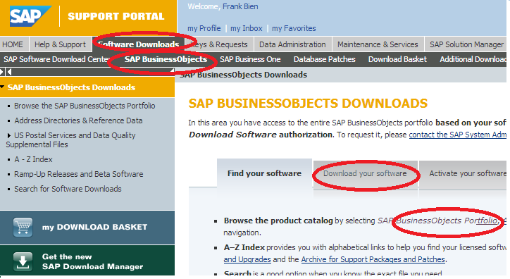

* + 1. Choose the “Install and Upgrade” link on the top of the next page. This expands the various SAP Business Object software tools and suites. Select “SBOP BI Platform (Enterprise)”.

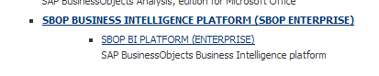

* + 1. After clicking “SBOP BI Platform (Enterprise)”, another web page is presented. Select “SBOP BI Platform 4.0”.

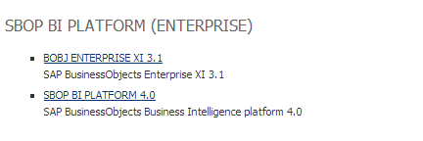

* + 1. Platform options for the installation are then displayed.

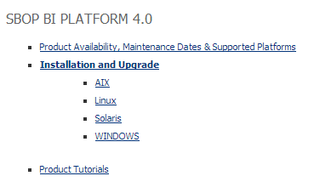

* + 1. Select the platform of choice. This selection presents corresponding SAP BOBJ server and other tools. Note that client tools are also listed here.

## Obtaining a BusinessObjects™ software license

The following steps show how to obtain a license key:

1. Login to the SAP® Support Portal website found below. This requires credentials in the form of a user id and password. These items can be obtained by contacting

<https://websmp206.sap-ag.de/bosap-downloads>

1. Click on the “Activate your software” link.

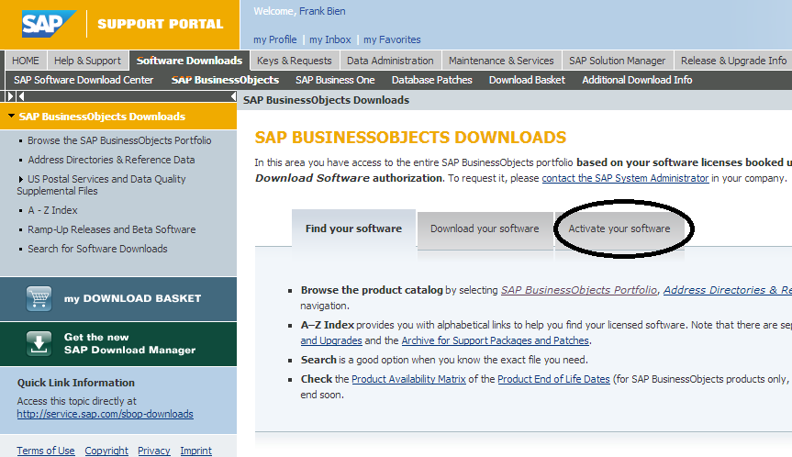

1. Click “license key request area” link. Choose “Obtain a temporary license key (ZIP file)” to download the file. Note that this is a zip file and contains a license key among other files.

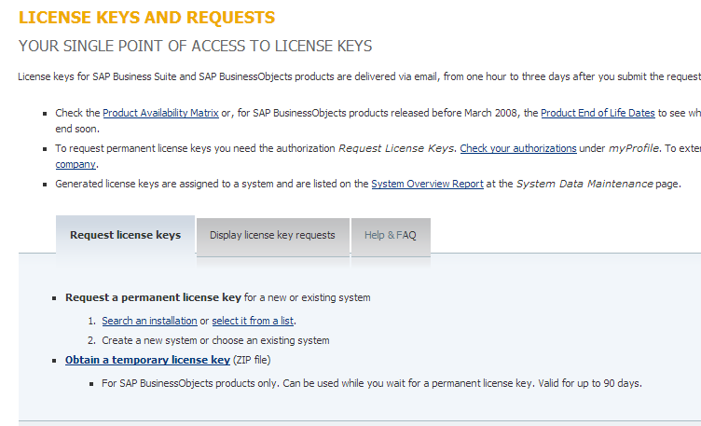

## Download the SAP® BusinessObjects™ client tools

Similar to the SAP® BusinessObjects™ server software, the client tools can be downloaded from the SAP website at:

<https://websmp206.sap-ag.de/bosap-downloads>

The following shows the steps used to download the required client tool software from the website:

1. Login to the SAP® Support Portal website found above. This requires credentials in the form of a user id and password. These items can be obtained by contacting
2. From the SAP® Support Portal page, select the “Software Downloads” tab, then “Download Your Software”, as shown.



1. Choose the “Install and Upgrade” link on the top of the next page. This expands the various SAP Business Object software tools and suites. Select “SBOP BI Platform (Enterprise)”.



1. After clicking “SBOP BI Platform (Enterprise)”, another web page is presented. Select “SBOP BI Platform 4.0”.



1. Platform options for the installation are then displayed.



1. Select the platform of choice. This selection presents corresponding SAP BOBJ server and other client tools.

## Identify the appropriate ODBC driver on Powerlink

Connectivity is established between the SAP® BusinessObjects™ server and the Greenplum database via an ODBC driver. The required driver for the configuration can be identified in either eLab Navigator utility or the EMC Support Matrix (ESM) for Greenplum found on the Powerlink website. The ESM is a PDF version of the information found in the eLab Navigator utility and contains certified combinations of the SAP® and Greenplum software. It also identifies the correct driver depending on which versions of will be installed. The eLab Navigator utility can be used to identify the appropriate ODBC driver and is found at:

<https://elabnavigator.emc.com/do/navigator.jsp>

The following steps are used to identify the certified combinations of Greenplum Database and SAP® BusinessObjects™ in the eLab Navigator tool:

1. Utilize the link above or navigate to the tool in Powerlink. From the main screen, the eLab Navigator is found by selecting “Support 🡪 Interoperability and Product Lifecycle Management 🡪 E-Lab Interoperability Navigator”.

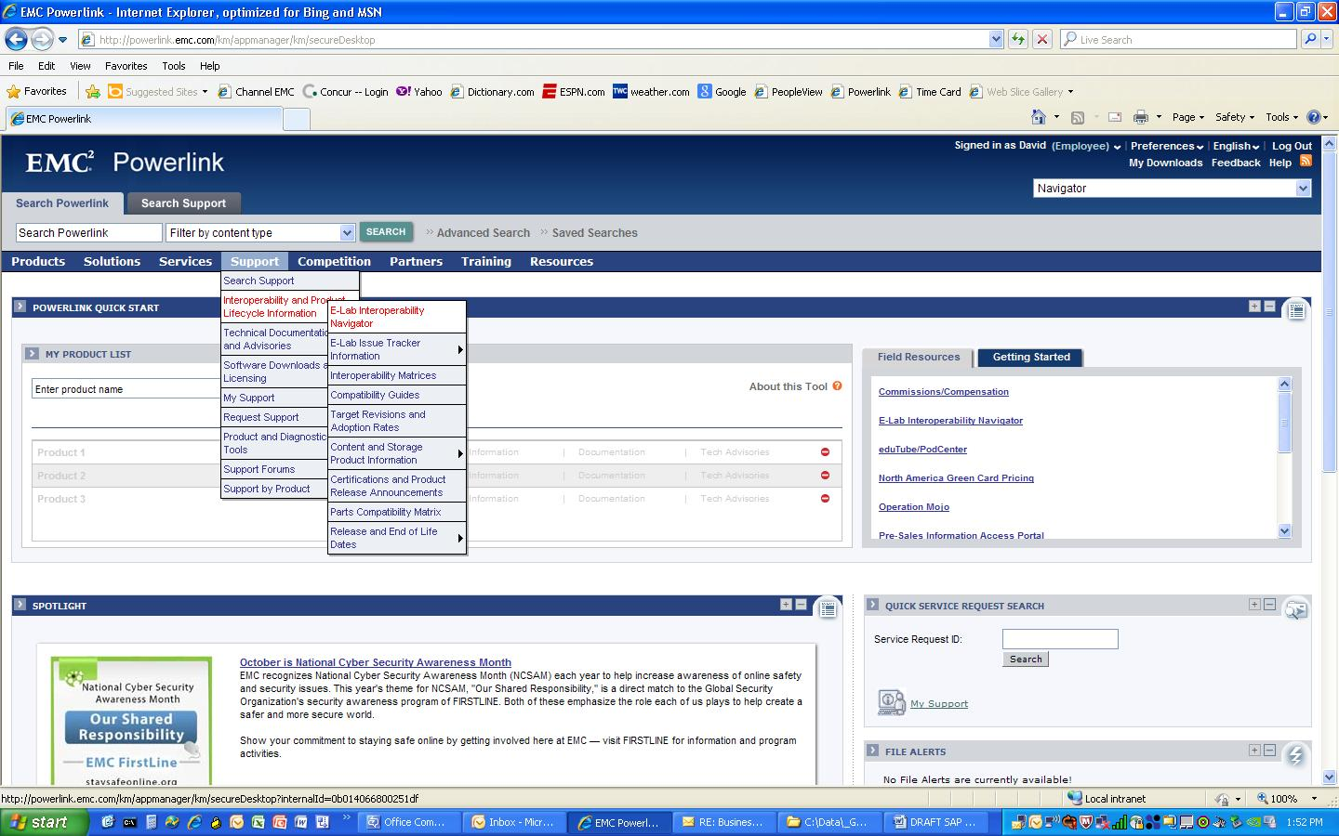

1. To start the utility, select the “Launch E-Lab Interoperability Navigator” on the page.

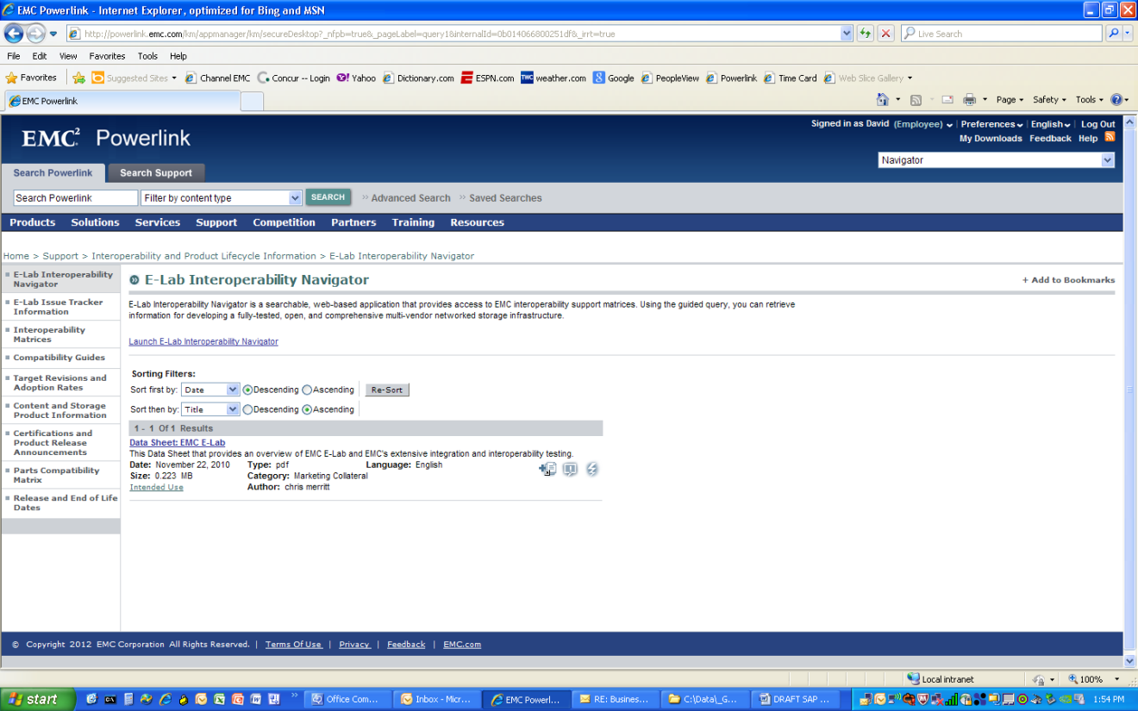

1. After launching the tool, type SAP in the Search field and hit the Search button. Note: the 3rd tab in the window is labeled “PDFs and Guides”. In this tab is located the PDF version of the EMC Support Matrix for Greenplum.

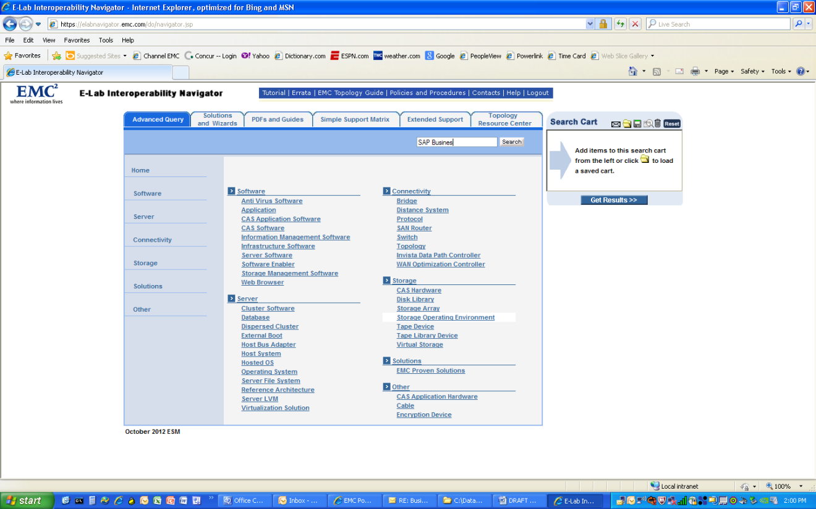

1. From the menu of products, check SAP® BusinessObjects™ 4.0 as shown.

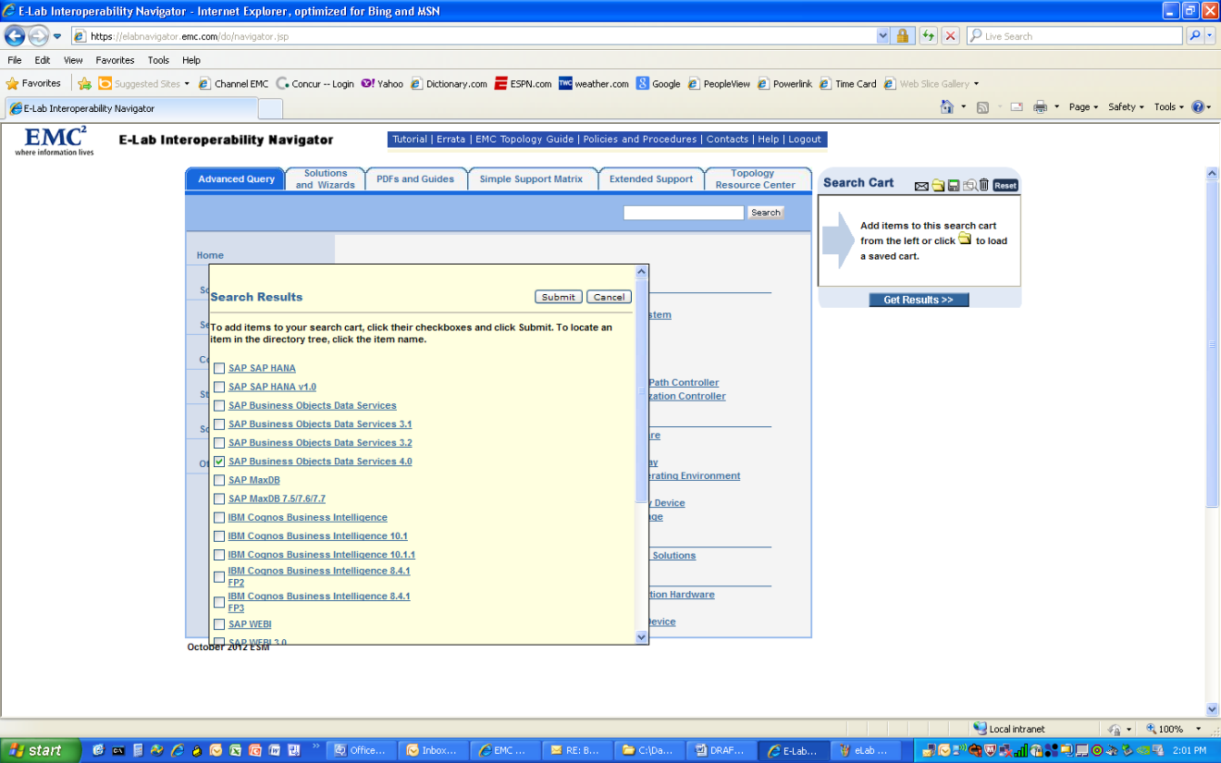

1. After hitting the submit button, SAP® BusinessObjects™ 4.0 is added to the Search Cart in the upper right of the window. To run the query, select the Get Results button.

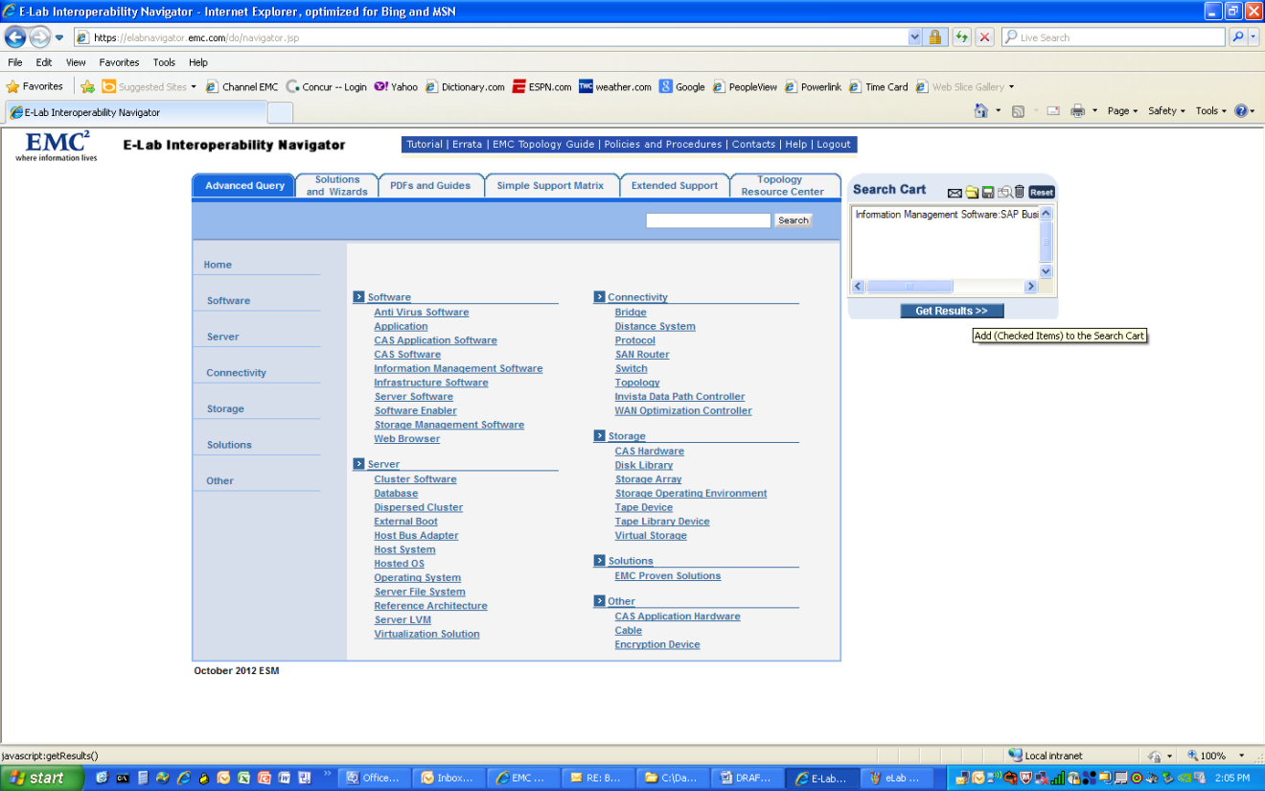

1. Results of the query can be found by select the All Support Statements link found on the right of the window. A new window showing the results of the query is brought up showing all supported configurations.

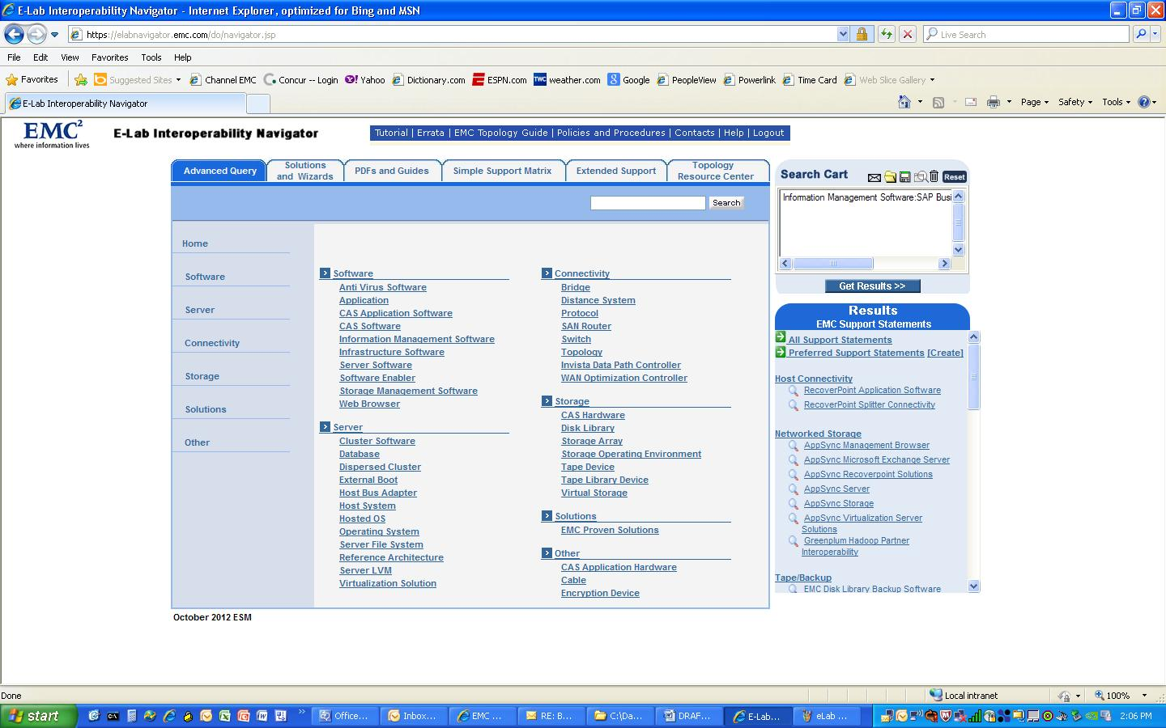

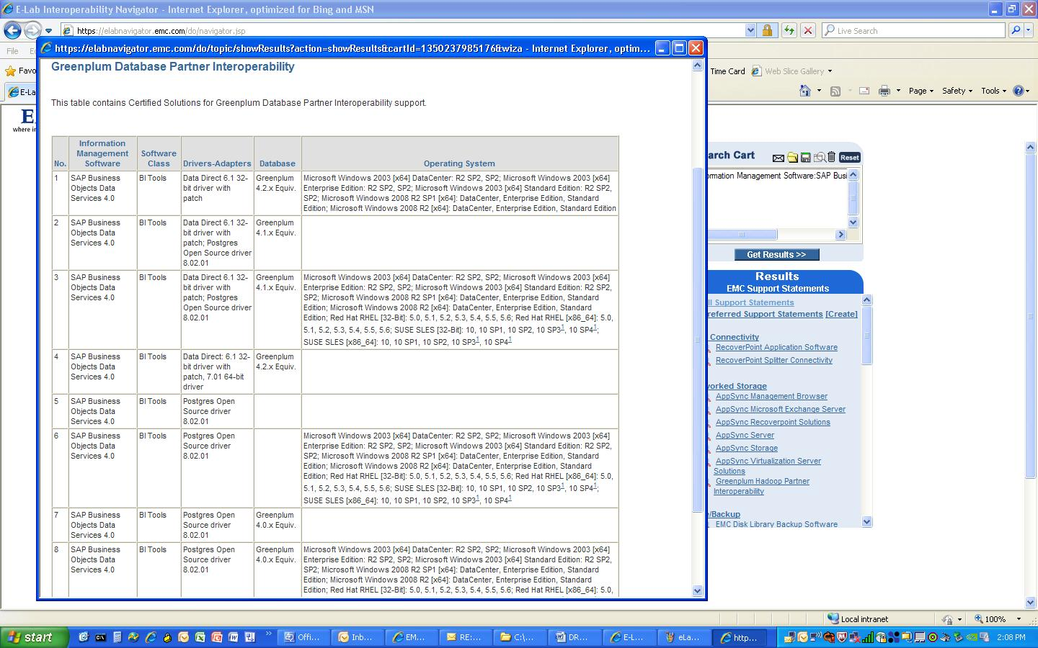

## Download the identified ODBC driver from Subscribenet

The Subscribenet website is EMC’s repository for many of their products including the Greenplum database software. Additionally, Greenplum provides a number of connectivity drivers for the database in the Greenplum Connectivity Pack. Customers gain access to purchased software (including the drivers) on Subscribenet via email. Internal EMC personnel can gain access to the site by contacting IT Central.

The Subscribenet website is found at:

<https://emc.subscribenet.com/control/dctm/index>

The following shows the process for accessing and downloading the Greenplum Database Connectivity Pack, which contains all drivers for a particular database version:

1. Make sure that you have login privileges to EMC Subscribe net site. If you do not have one or need any assistance call 1-800-782-4362. The same info is available through “About EMC Software Support” link on subscribe net main page. Login into the Subscribenet website.

1. Navigate to the Greenplum software download screen.

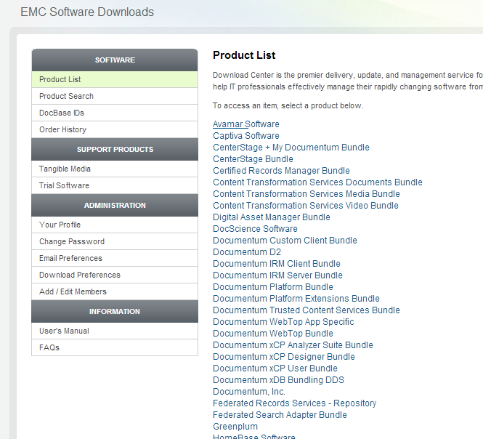

1. Select the Greenplum database software version to be installed.
2. Identify the Connectivity Pack software associated with the database software.

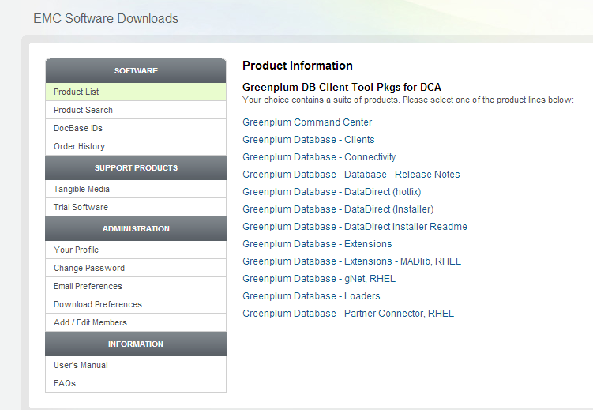

The third link on the right part of the screen, “Greenplum Database – Connectivity” contains the Greenplum connectivity package which includes the Open Source ODBC drivers, etc.

The fifth and sixth links contain the Data Direct drivers, one for the installer and one for any hot fixes required. These drivers are recommended for connectivity between Greenplum and SAP® BusinessObjects™ 4.0 although the Open Source drivers are sometimes requested by customers. A portion of the final web page screen is shown below for reference.

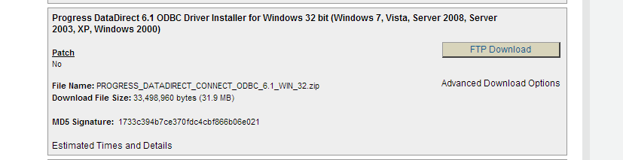

For SAP® BusinessObjects™, a 32-bit ODBC driver is needed. These are downloaded by choosing the FTP download button in the window.

## Install the pre-requisite SAP® BusinessObjects™ application host software

Use the following guidelines when you install SAP® BusinessObjects™Business Intelligence platform:

* Ensure that the operating system is supported. Only 64-bit operating systems are supported.
* Windows .NET Framework 3.5 Service Pack 1 and Windows installation program 4.5 are required.
* Before you run the installation program, ensure that the destination partition has enough room for the deployment to expand (when updates and new features are added in the future).
* If you install the deployment on the operating system partition, ensure that there is enough room for the deployment and the operating system. It is recommended that you have at least 2 gigabytes available for temporary files and web applications.
* If you have previously installed any SAP BusinessObjects products, the installation program uses the existing directory.
* Ensure that the file path of the directory where you run the installation program is less than 280 characters in length.

For a detailed list of supported operating systems and hardware requirements, consult the Supported Platforms documentation available at <http://service.sap.com/bosap-support>.

## Install the BusinessObjects™ software

SAP® BusinessObjects™ requires a 64-bit Windows application host. The EMC Support Matrix (ESM) for Greenplum details the operating systems supported. The following shows the steps required to successfully install the SAP® BusinessObjects™ software on a Windows 2008 64-bit host:

1. The first step is to unzip the software in the installation directory.
2. The next step in the installation process is to start the installer and select the required client components.



1. The Greenplum database should be checked in the Select Features window.



1. The installation of the software then proceeds.



1. The installer identifies success once the process completes.



## Install the ODBC driver

Connectivity between SAP® BusinessObjects™ and the Greenplum database requires installation of the ODBC driver. Although the SAP® BusinessObjects™ server is a 64-bit version, the ODBC driver used for connectivity is 32-bit. To differentiate between the 32 and 64-bit drivers, the Data Direct 64-bit ODBC driver software uses file names starting with DD while the 32-bit drivers start with IV. This difference, along with the steps for installing and configuring the ODBC driver, are show below:

1. Verify that the correct driver files are available. The correct files should start with the letters “IV”, for the 32-bit version, rather than “DD”, that designates a 64-bit version. These driver files are self executables whereas UNIX based ones are tar files. Double click windows executable to start installation.

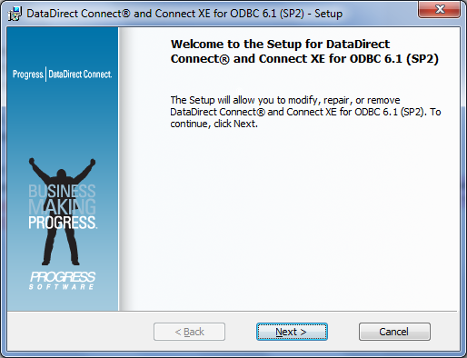

1. Click “Next” to start installation and select the defaults for each of the pop-up boxes.
2. Make sure to fill the correct license key at “EVAL” (2 locations). Key information is also available at the same location on EMC subscribe net.

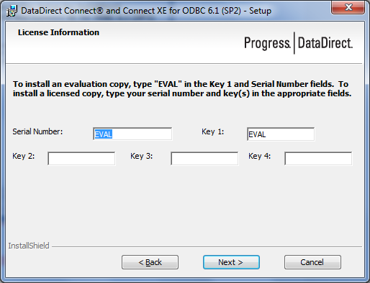

1. License info is available at the seventh link on the right.

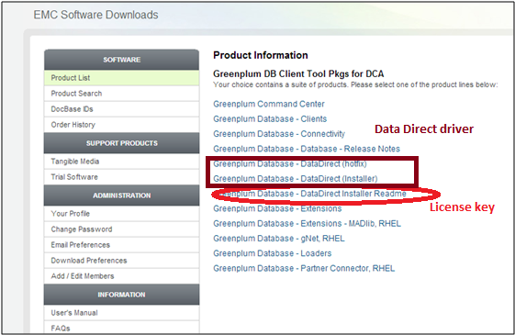

1. Click “DataDirect Installer Readme” link to download the PDF file. Note that this file not only has installation instructions, also contains the license key.
2. Click “Yes” to install this software.

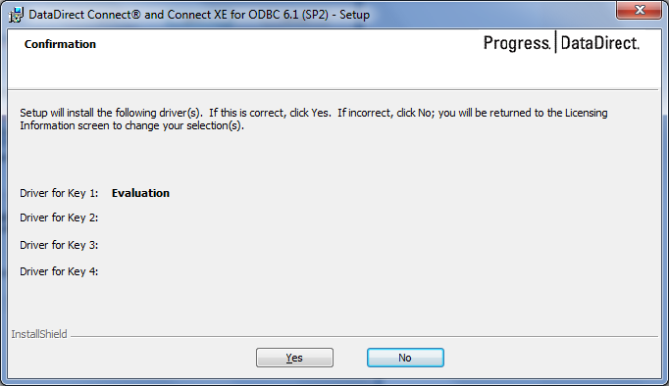

## Validate the ODBC driver

Once the driver has been installed, the next step in the process is to validate the driver. The driver is validated by verifying installation in the ODBC driver configuration window and by testing connectivity between SAP® BusinessObjects™ and the Greenplum database.

1. Start 32-bit ODBC administrator. This is located at C:\Windows\SysWOW64\odbcad32.exe by default. Note that 64-bit ODBC administrator may be selected by default, if you do not specify full path.

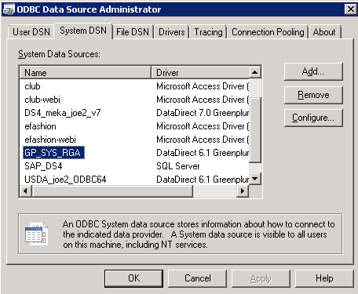

Note that “System DSN” entries are preferred over “User DSN” as they can be shared with other users. For additional information on 32-bit versus 64-bit ODBC drivers, please refer to Confluence page referenced in the reference appendix.

1. Click on ‘Drivers’ tab to check corresponding DLL that is getting used by this driver. Note that DDL or file loaded by your ODBC driver manager can be different as new ODBC drivers are released.

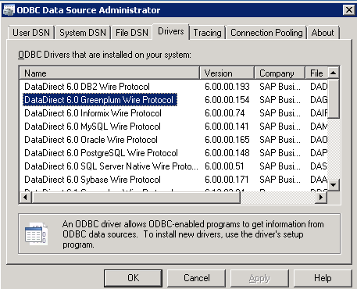

1. Double click the DSN and this open another dialog box. Click on ‘Test Connect’ and supply login / password to verify the ODBC connection.

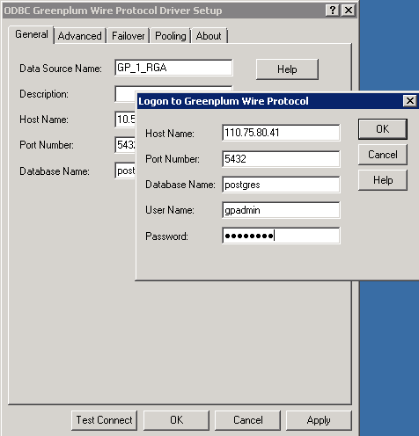

1. The following screen is displayed if ODBC connectivity is successful.

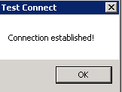

# Solution Testing

This section describes the steps needed to test and validate the SAP® BusinessObjects™ and Greenplum database solution.

Three steps are needed to validate that the SAP® BusinessObjects™ environment is ready to test in. They include:

1. Creating a 32-bit ODBC connection to the Greenplum database
2. Starting the BusinessObjects™ Information Design Tool (IDT) and create a project
3. Universe creation through Universe Design Tool (UDT).
4. Report design through web rich client tool.

These 3 steps are shown in more detail below.

## Creating a new 32-bit ODBC connection to Greenplum

A connection between SAP® BusinessObjects™ and the Greenplum database is required to create reports and run them. Please see above section “Validate ODBC driver” for further details on ODBC connectivity.

## Starting the Information Design Tool

1. Start ‘Information Design Tool’ by choosing from the list.

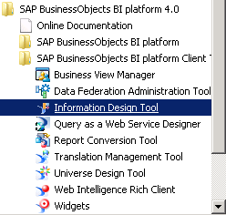

1. Login to this tool using proper credentials. Note that this is a client tool and the server can be running elsewhere; in this case, server details are different.
2. After login to Information design tool, create a new connection (File / Relation Connection). If there is no existing project, you may be required to create a new project. This can be done by choosing (File / Project). Follow this with connection creation and continue as given below.

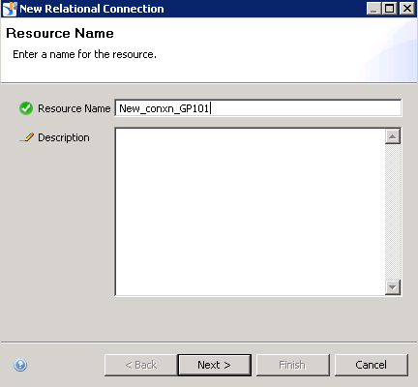

1. This opens a new dialog box as shown below.

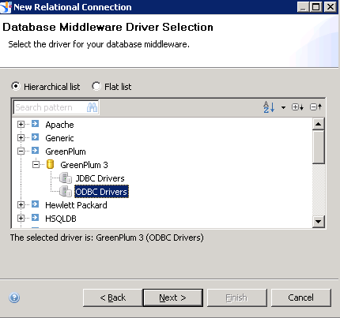

1. Click ‘Next’ to get the following dialog box.

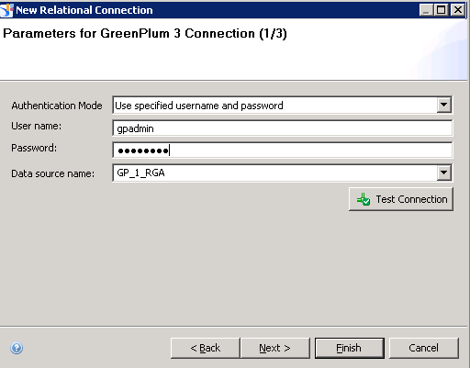

1. Click “Next” to get the following dialog box.

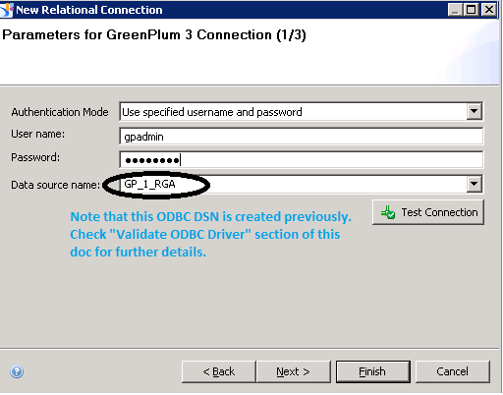

1. Click “Next” (to customize settings) or “Finish” (for default settings).

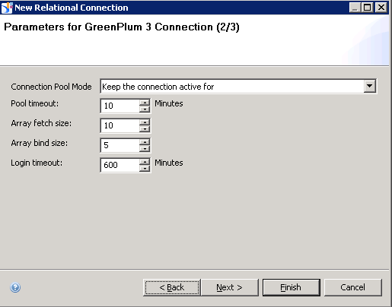

The following table explains each setting more clearly.

|  |  |
| --- | --- |
| Connection pool mode | From the drop down list, select the method to use to keep the connection active. Only necessary if using a connection pool. |
| Pool timeout | If you select Keep the pool active for in the previous field, specifies the length of time to keep the connection open. |
| Array fetch size | Enter the maximum number of rows authorized with each fetch.  If you enter 20, and your query retrieves 100 rows, the connection executes 5 fetches to retrieve your data.  If you enter 1, array fetch is deactivated and data is retrieved row by row.  Note: Deactivating array fetch is the safest way of retrieving your data but row-by-row retrieval slows down server performance. The greater the value in the Array fetch size option, the faster your rows are retrieved. You must, however, ensure you have adequate client system memory.  The default value is 20. |
| Array bind size | Enter the size of the bind array that Connection Server uses before sending to the repository. The bind array is the area in memory where Connection Server stores a batch of data to be loaded (sent to the repository). When the bind array fills, it is transmitted to the database. Generally, the larger the bind array, the more rows (n) can be loaded in one operation, and the better your performance. |
| Login timeout | Specifies the number of seconds before a connection attempt times out and an error message is displayed. |
| String maximum size | For connection to sources that are not relational databases, such as text files or Excel files, this parameter defines the size that will be returned for all strings, no matter what their real size. The default value is 1024. |

The Configuration Parameters dialog box contains parameters that you can set to override default configuration options. These configuration parameters override:

* Any corresponding parameters set in the cs.cfg file
* Any corresponding parameters set in the <driver>.sbo file.

1. Additional parameters can be entered at the next screen.

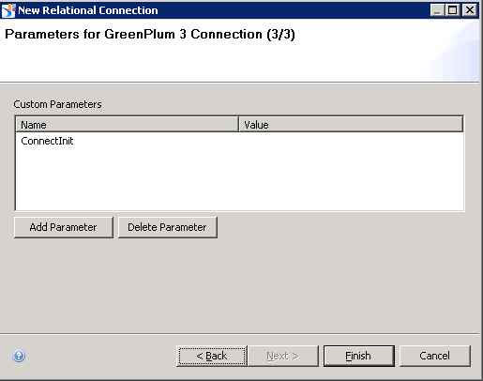

1. The next phase of using IDT involves creating physical layer (this is a non-BOBJ terminology and refers to typical BI reporting tools which separate database physical or table information from tool logical models). Choose ‘File / New Data Foundation’ from the menu. Select ‘Single Source’ as we typically pull out of Greenplum these details.

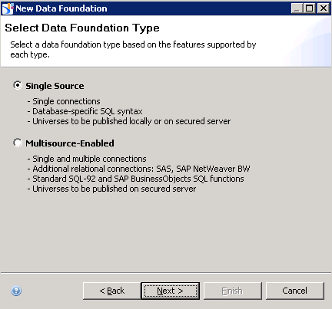

Choose the connection that already established in the steps above.

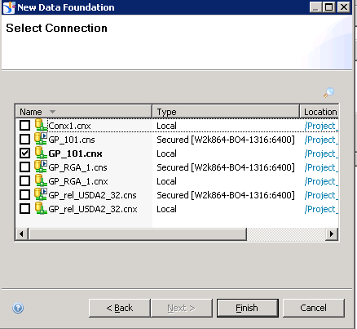

1. Expand the contents in “Connection” frame and drag / drop them to canvas on the right (shown as “Master” in the screen).

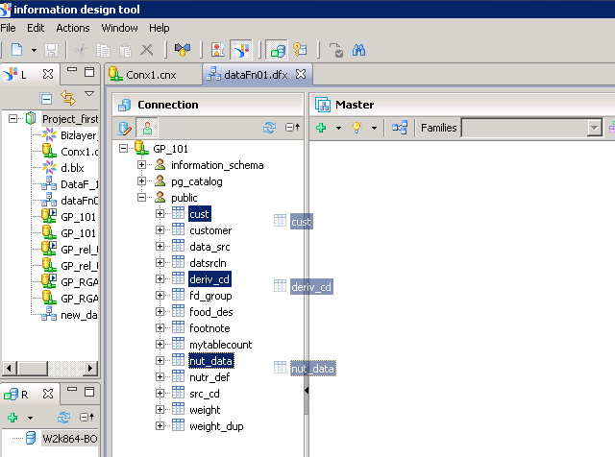

1. Next step is to choose ‘Business Layer’ (File / Business Layer). This is similar to a logical layer BI tools create for separating table or database physical structure from logical model that BOBJ creates in this step.

1. Select ‘Relational Data Source’ in the next dialog box.

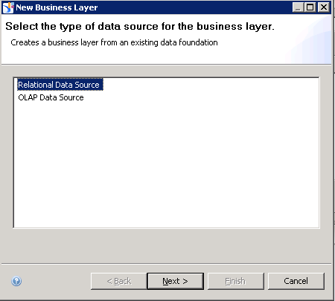

1. Provide a resource name.

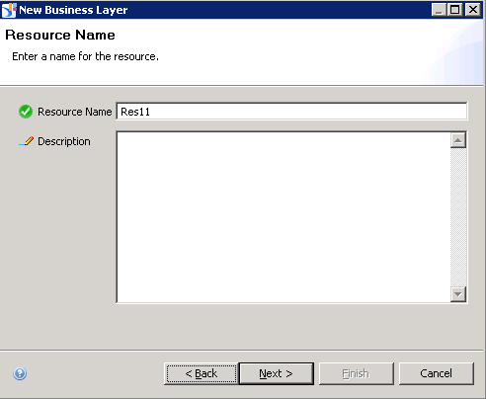

1. Choose ‘Data Foundation’ that was created above.

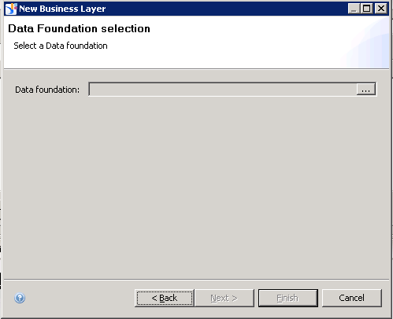

1. Click on “…” button above to open the data foundation setting. This opens IDT with ‘Business Layer’ frame.

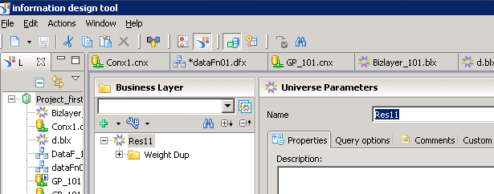

1. Note that you can turn fields into measures (that allow aggregation) by right clicking on them.

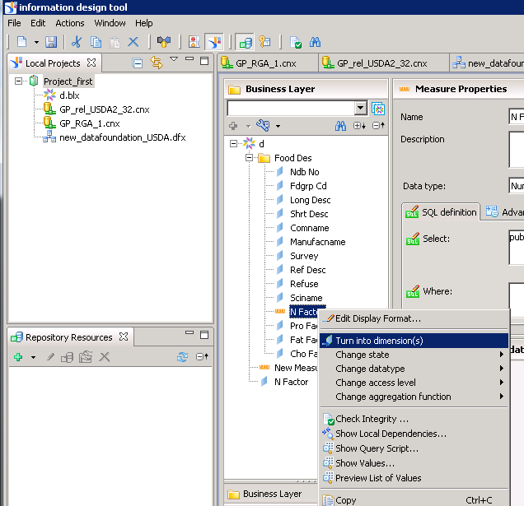

1. Publish business layer locally. A UNX file will be created at the corresponding location, which includes connectivity, data and business foundation encapsulated.

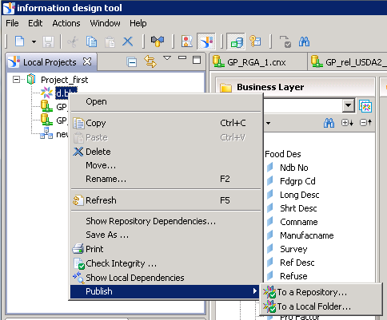

## Universe Design Tool

This tool is useful in creating a universe and running quick reports.

1. Login to Universe Design Tool using credentials. Note that these are the same ones that were used while Business Objects installation.

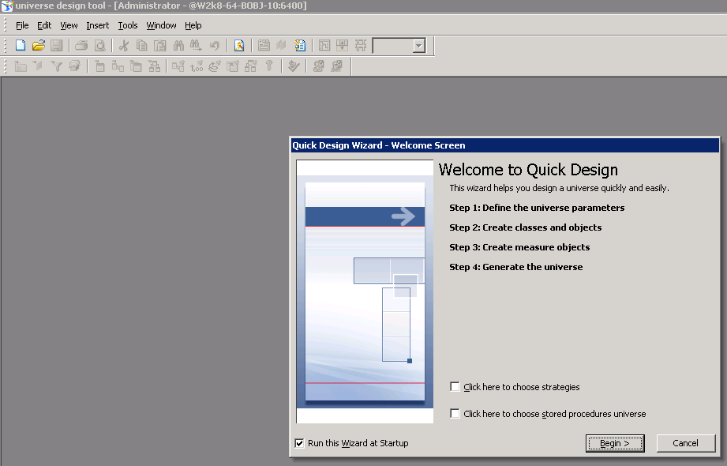

This opens the tool with a wizard; choose Begin to start Universe design. Alternatively, close this dialog box and use ‘File / Open’ to start a new universe design.

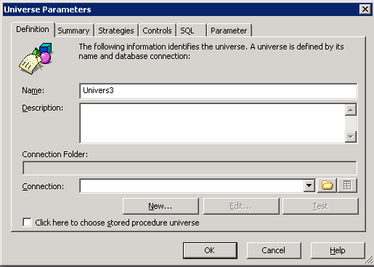

1. Click “New” to establish a new connection and follow the settings as indicated below.

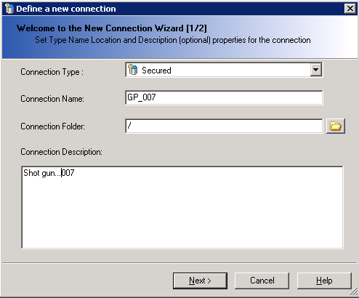

1. Click ‘Next’ displays different database middleware options.

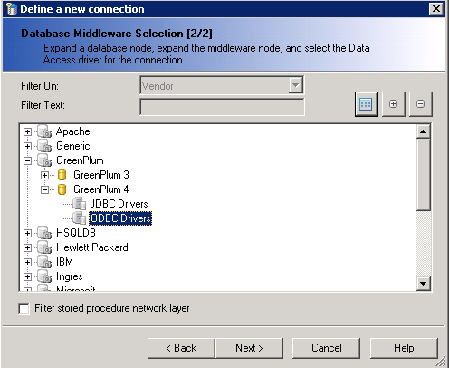

1. A new dialog box opens in which we can choose Greenplum credentials and ODBC DSN setting. Note that this DSN is previous established; check “Validate ODBC driver” section on how to establish this connectivity.

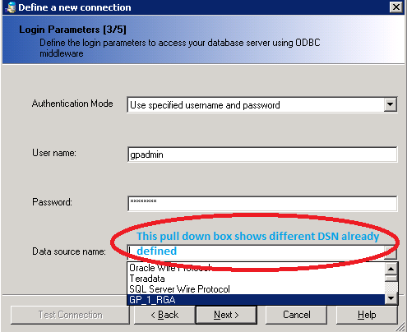

1. Choose default settings for the next two screens; these were already discussed under IDT section above.
2. Upon completion, click “Test” button to ensure login can be done.

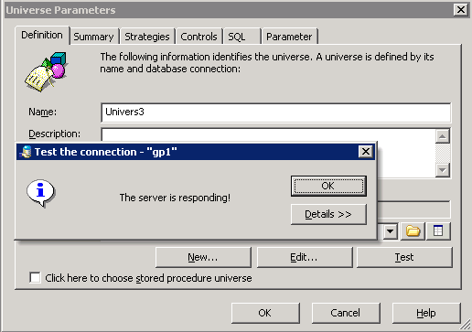

A number of options are available from the Universe parameters dialog box as shown below.

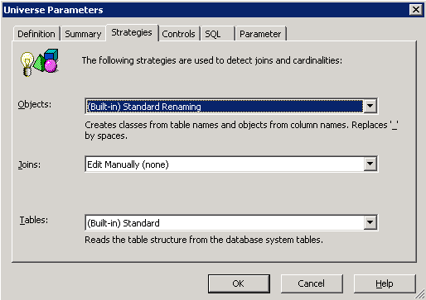

Below is a brief explanation of some of the items from above.

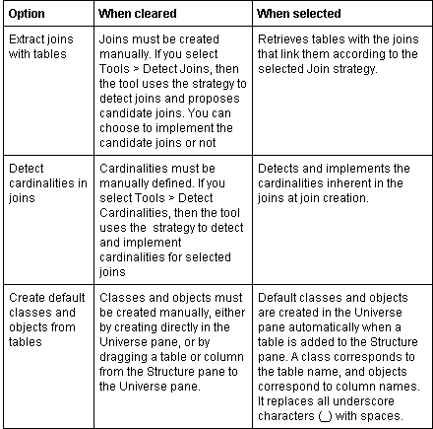

Controls options were already discussed under IDT, please check this section above.

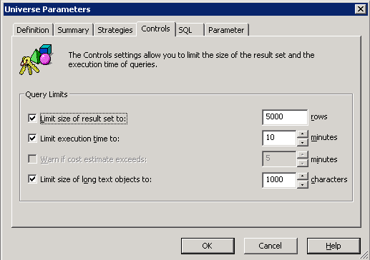

The following shows the options on the SQL tab.

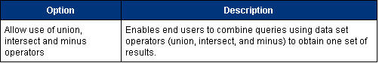

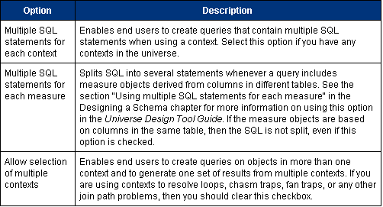

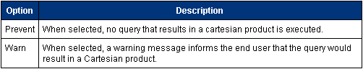

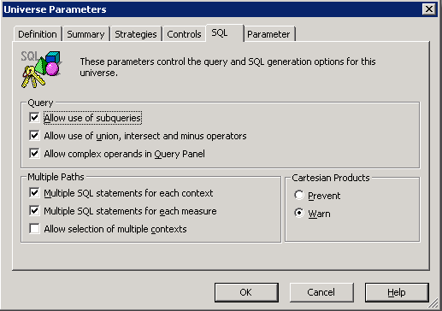

The Parameter tab is useful when passing parameters while running reports.

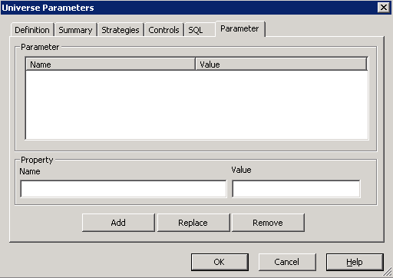

1. UDT presents a blank canvas on which we can right click to choose ‘Tables’.

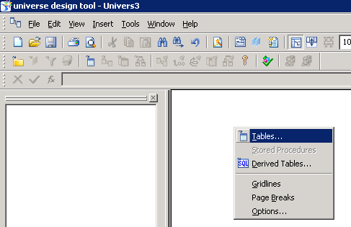

Choose as many tables from the list and they will appear on the right side. Make sure to drag them to the left side to make these available in a universe. Save option from File / Save publishes them at the server level.

Universes are available to client tools such as web rich client; see section below for further details.

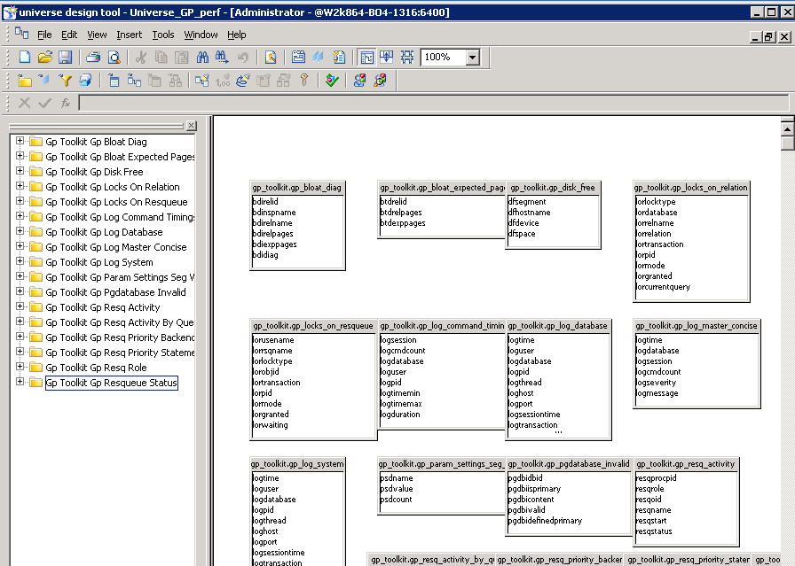

## Web Rich Client

1. Start a web rich client or any reporting tool that allows us to use this universe from the repository. Click on browse button, and choose universe and then get connected to BOBJ server.

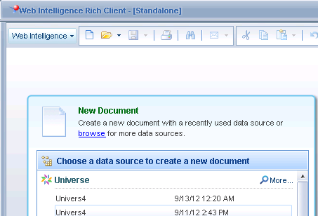

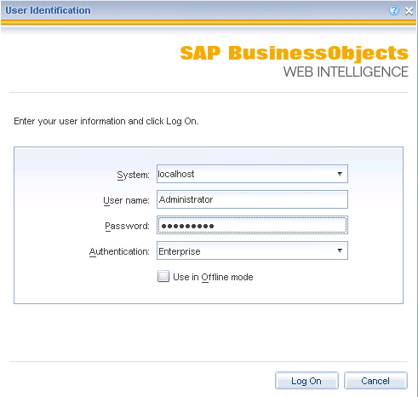

1. A new universe is available from this list. Refresh universe list if a new one is not visible.

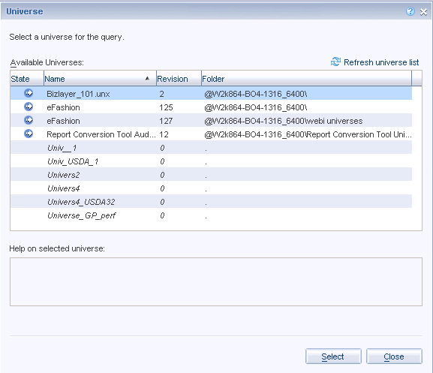

1. Double click the query panel and drop a few columns to generate a quick report; Run Query button is at the top right.

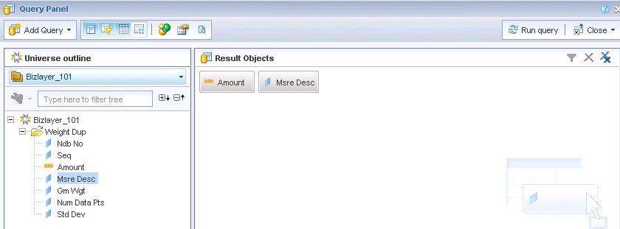

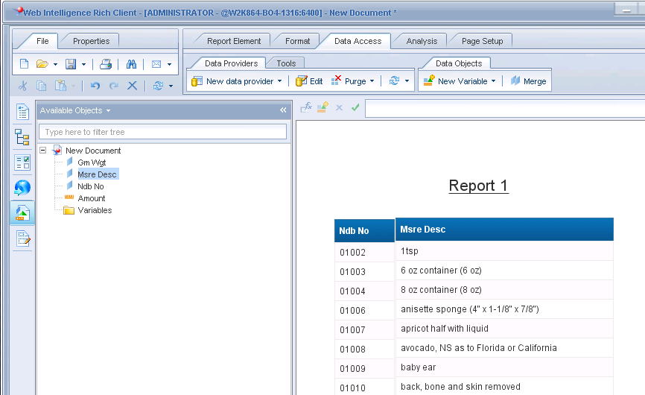

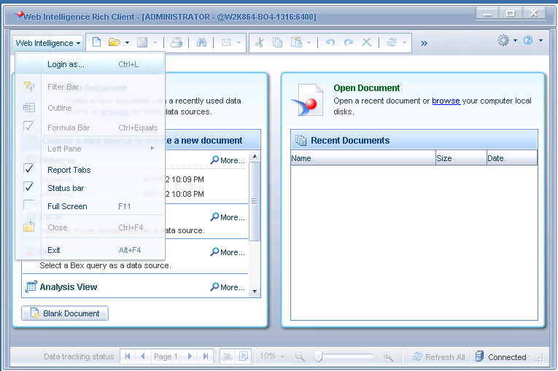

Drag a table object to Result Objects (from left frame to top right area) and create a report. Click ‘Run Query’ button located at the top right gives this output.

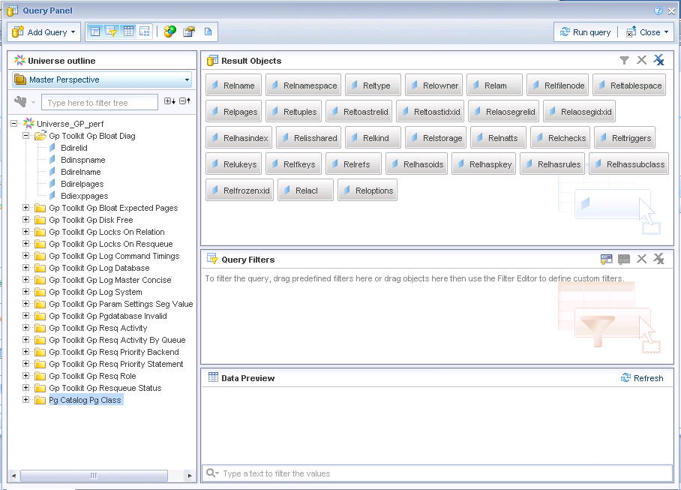

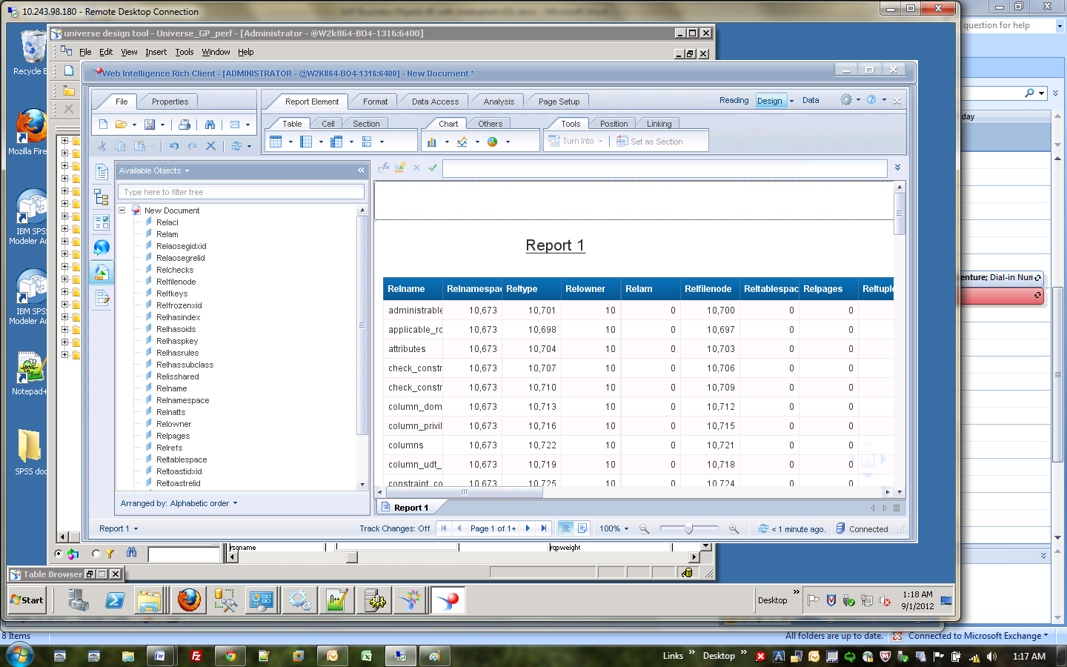

==================

# Performance Tuning

Maximizing performance with SAP® BusinessObjects™ in a Greenplum environment is a primary concern for many customers. This section describes a number of performance tuning options and considerations.

SAP® BusinessObjects™ can be tuned in 4 layers of the stack. They include:

1. Universal level tuning
2. SQL generation tuning
3. Report level tuning
4. ODBC PRM file tuning

Steps for tuning each of these areas is described below.

**Universal level tuning**

Connection pools to SAP® BusinessObjects™ can be tuned either when the universe is created or by choosing the File / Parameters dialog box and then selecting the Connection and Edit options.



Options for these configuration parameters include:

|  |  |
| --- | --- |
| Array fetch size | Enter the maximum number of rows authorized with each fetch.  If you enter 20, and your query retrieves 100 rows, the connection executes 5 fetches to retrieve your data.  If you enter 1, array fetch is deactivated and data is retrieved row by row.  Note: Deactivating array fetch is the safest way of retrieving your data but row-by-row retrieval slows down server performance. The greater the value in the Array fetch size option, the faster your rows are retrieved. You must, however, ensure you have adequate client system memory. |
| Array bind size | Enter the size of the bind array that Connection Server uses before sending to the repository. The bind array is the area in memory where Connection Server stores a batch of data to be loaded (sent to the repository). When the bind array fills, it is transmitted to the database. Generally, the larger the bind array, the more rows (n) can be loaded in one operation and the better the performance. Typically not applicable to an environment unless a connection to the server already exists. |
| Login timeout | Specifies the number of seconds before a connection attempt times out and an error message is displayed. |
| String maximum size | For connection to sources that are not relational databases, such as text files or Excel files, this parameter defines the size that will be returned for all strings, no matter what their real size. The default value is 1024. |

**SQL generation tuning**

An important performance tuning area for SAP® BusinessObjects™ is ensuring that the SQL generated by the software that is sent to the Greenplum database is optimal. SQL generation parameters are managed through the Information Design Tool (IDT), as shown in the diagram below. The following parameters are available to ensure optimized SQL generation:



ANSI92 = Yes|No

|  |  |
| --- | --- |
| Values | Yes/No |
| Default | No |
| Description | Specifies whether the SQL generated complies to the ANSI92 standard.  Yes: Enables the SQL generation compliant to ANSI92 standard.  No: SQL generation behaves according to the PRM parameter OUTER_JOIN_GENERATION. |

AUTO_UPDATE_QUERY = Yes|No

|  |  |
| --- | --- |
| Values | Yes/No |
| Default | No |
| Description | Determines what happens when an object in a query is not available to a user profile.  Yes: Query is updated and the object is removed from the query.  No: Object is kept in the query. |

BEGIN_SQL = <String> (not sure how this can be useful for GPDB)

|  |  |
| --- | --- |
| Values | String |
| Default | Empty string |
| Description | This is used to prefix SQL statements for accounting, prioritization, and workload management. This parameter applies to any SQL generation, including document generation and LOV queries. It is supported in Web Intelligence and is ignored by Desktop Intelligence and Crystal Reports.  Example for Teradata:  BEGIN_SQL=SET QUERY_BAND='string' for transaction;  This parameter requires a string that contains one or more name-value pairs, separated by a semicolon, all inside single quotes. All SQL statements are prefixed with the parameter that follows BEGIN_SQL. The name-value pairs entered in this parameter are written in the GetQueryBandPairs system table.  Example of three name-value pairs:  BEGIN_SQL=SET QUERY_BAND='UserID=Jones;JobID=980;AppID=TRM' for transaction;  You can also use the @Variable function as the value in the name-value pair, the returned value is enclosed in single quotes: BEGIN_SQL=SET QUERY_BAND='USER='@Variable('BOUSER');Document='@Variable('DPNAME')';' for transaction; |

BLOB_COMPARISON = Yes|No

|  |  |
| --- | --- |
| Values | Yes/No |
| Default | No |
|  |  |
| Description | Species if a query can be generated with a DISTINCT statement when a BLOB file is used in the SELECT statement. It is related to the setting No Duplicate Row in the query properties.  Yes: The DISTINCT statement can be used within the query.  No: The DISTINCT statement cannot be used within the query even if the query setting No Duplicate Row is on. |

BOUNDARY_WEIGHT_TABLE = Integer 32bits [0-9]

|  |  |
| --- | --- |
| Values | Integer 32bits [0-9, or a negative integer] |
| Default | -1 |
| Description | Allows you to optimize the FROM clause when tables have many rows.  If the table size (number of rows) is greater than the entered value, the table is declared as a subquery:  FROM (SELECT col1, col2,......, coln, ,...., FROM Table_Name WHERE simple condition).  A simple condition is defined as not having a subquery.  -1, 0, or any negative number means that this optimization is not used. |
| Limitations | Optimization is not implemented when:   * The operator OR is in the query condition * Only one table is involved in the SQL * The query contains an outer join * No condition is defined on the table that is being optimized * The table being optimized is a derived table. |

COLUMNS_SORT = Yes|No

|  |  |
| --- | --- |
| Values | Yes/No |
| Default | No |
| Description | Determines the order that columns are displayed in tables in the Structure pane.  Yes: Columns are displayed in alphabetical order  No: Columns are displayed in the order they were retrieved from the database |

CUMULATIVE_OBJECT_WHERE = Yes|No

|  |  |
| --- | --- |
| Values | Yes|No |
| Default | No |
| Description | This parameter applies to filtered objects only. Specifies how to combine the objects WHERE clause with the query condition on those objects.  Yes: Specifies that WHERE clauses are combined with the main query condition with the AND operator.  No : Specifies that the object's WHERE clause is combined with the condition for this object.  Example:  If the condition is find all French clients different from John or American cities different from New York, the SQL is:  Yes:  (customer.first_name <>  'John')  OR (city.city <> 'New York  AND customer_country.country = 'France'  AND city_country.country = 'USA'  No:  (customer.first_name <> 'John' AND  customer_country.country = 'France'  )  OR (city.city <> 'New York' AND  city_country.country = 'USA'  ) |

DISABLE_ARRAY_FETCH_SIZE_OPTIMIZATION = Yes|No

|  |  |
| --- | --- |
| Values | Yes/No |
| Default | No |
| Description | An optimization algorithm can be used to optimize the size of the returned arrays instead of using the default setting.  No: All queries run on the universe will benefit from the optimization.  Yes: Queries use the default value set. |

DISTINCT_VALUES = GROUPBY|DISTINCT

|  |  |
| --- | --- |
| Values | GROUPBY|DISTINCT |
| Default | DISTINCT |
| Description | Specifies whether SQL is generated with a DISTINCT or GROUP BY clause in a list of values and Query pane when the option "Do not retrieve duplicate rows" is active.  DISTINCT: The SQL is generated with a DISTINCT clause, for example;  SELECT DISTINCT cust_name FROM Customers  GROUPBY: The SQL is generated with a GROUP BY clause, for example;  SELECT cust_name FROM Customers GROUP BY cust_name |

END_SQL = String

|  |  |
| --- | --- |
| Values | String |
| Default | <empty string> |
| Description | The statement specified in this parameter is added at the end of each SQL statement. |
| Example | For IBM DB2 databases, you can use the following:  END_SQL=FOR SELECT ONLY  The server will read blocks of data much faster.  Another example:  END_SQL=’write ‘ UNVID To Usage_Audit.Querieded_universe  Would write universe id to an audit table, this can be used to record other data such as user and tables queried. |

EVAL_WITHOUT_PARENTHESIS = Yes|No

|  |  |
| --- | --- |
| Values | Yes|No |
| Default | No |
| Description | By default, the function @Select(Class\object) is replaced by the SELECT statement for the object <Class\object> enclosed within brackets.  For example, when combining two @Select statements, @Select(objet1) *@Select(objet2).  If the SQL(object1) = A-B and SQL(object2) =C,  then the operation is (A-B) * (C).  You avoid the default adding of brackets by setting EVAL_WITHOUT_PARENTHESIS = Yes. The operation is then A - B * C.  Yes: Brackets are removed from the SELECT statement for a function @Select(Class\object)  No: Brackets are added around the Select statement for the function @Select(Class\object). |

FORCE_SORTED_LOV = Yes|No

|  |  |
| --- | --- |
| Values | Yes|No |
| Default | No |
| Description | Retrieves a list of values that is sorted.  Yes: Specifies that the list of values is sorted.  No: Specifies that the list of values is not sorted. |

INNERJOIN_IN_WHERE = Yes|No

|  |  |
| --- | --- |
| Values | Yes|No |
| Default | No. You must manually add the parameter to activate it. |
| Description | Allows you to force the system to generate SQL syntax with all the inner joins in the WHERE clause when ANSI92 is set to yes . This is only possible if a query contains only inner joins (Does not contain FULL OUTER, RIGHT OUTER, or LEFT OUTER joins).  Yes: If ANSI92 is set to yes, the system generates ANSI92 join syntax in the FROM clause except when the query contains only inner joins. In this case, the inner joins go into the WHERE clause.  No: If ANSI92 is set to Yes, the system generates ANSI 92 join syntax in the FROM clause. |

JOIN_BY_SQL = Yes|No

|  |  |
| --- | --- |
| Values | Yes|No |
| Default | No |
| Description | Specifies how multiple SQL statements are handled. Multiple statements can be combined (provided that the database permits this).  Yes: Specifies that multiple SQL statements are combined.  No: Specifies that multiple SQL statements are not combined. This is the default value. |

MAX_INLIST_VALUES = [0-99]

|  |  |
| --- | --- |
| Values | Integer: min-1, max depends on DB |
| Default | -1 |
| Description | Allows you to set the maximum number of values you may enter in a condition when you use the IN LIST operator.  99: Specifies that you may enter up to 99 values when you create a condition using the IN LIST operator.  The maximum authorized value you may enter depends on your database.  The value of -1 means that there is no restriction on the number of values returned, except that imposed by the database. |

REPLACE_COMMA_BY_CONCAT= Yes|No

|  |  |
| --- | --- |
| Values | Yes|No |
| Default | No |
| Description | In previous versions of the universe design tool, a comma could be used to separate multiple fields in an object Select statement. The comma was treated as a concatenation operator. For universes that already use the comma in this way you can set REPLACE_COMMA_BY_CONCAT to No to keep this behavior. In the current version of the universe design tool, this parameter is set to Yes by default, so that any expressions using a comma in this way are automatically changed to use concatenation syntax.  Yes: Comma is replaced by the concatenation expression when multi field object is found.  No: Keep the comma as it is. |

SELFJOINS_IN_WHERE = Yes|No

|  |  |
| --- | --- |
| Values | Yes|No |
| Default | No |
| Description | Self-joins are usually included in the FROM clause. This allows you to force the system to generate SQL syntax with all the conditions of a self-join in the WHERE clause. The ANSI92 parameter must be set to Yes for this parameter to be taken into account.  You must manually add the parameter to the list to activate it.  Yes: The conditions of a self-join go in the WHERE clause of the SQL query.  No: The syntax for self-joins is generated according to the ANSI 92 convention, and conditions for a self-join go in the ON clause of the table join definition in the FROM clause of the SQL query. |

SHORTCUT_BEHAVIOR = ShortestPath|Global|Successive

|  |  |
| --- | --- |
| Values | ShortestPath|Global|Successive |
| Default | ShortestPath |
| Description | Specifies how shortcut joins are applied.  ShortestPath: applies shortcuts so as to obtain the smallest number of tables in the query.  Successive: applies shortcuts one after the other. If a shortcut removes a table involved in a potential successive shortcut, the successive shortcut is not applied.  Global: applies all shortcuts. If the resulting query creates a Cartesian product, no shortcut joins are applied.  Note: This parameter was formerly listed as GLOBAL_SHORTCUTS in the PRM files. The value Global corresponds to Yes, and Successive corresponds to No. |

SMART_AGGREGATE = Yes|No

|  |  |
| --- | --- |
| Values | Yes|No |
| Default | No |
| Description | Determines how aggregate tables are used for smart measures that are based on an aggregate tables. This ensures that a universe object based on a ratio is correctly aggregated. By default the system takes the advantage of the pre-calculated values from the aggregated tables, if these table are not consistent during time (different time periods), you use this parameter to ensure the most detailed aggregate tables are used.  This parameter is not visible in the universe parameter list (by default not activated). The universe designer must manually insert it in the parameter list before activating it (value Yes).  Yes: Any additional grouping set query should be based on the aggregate table of the initial query for the smart measure based on aggregate table.  No: The system takes the most appropriate aggregate table. |

THOROUGH_PARSE = Yes|No

|  |  |
| --- | --- |
| Values | Yes|No |
| Default | No |
| Description | Specifies the methodology used for default Parsing in the Query pane and individual object parsing.  Yes: PREPARE, DESCRIBE, and EXECUTE statements are used to parse SQL for objects.  Prepare+DescribeCol+Execute  No: PREPARE and DESCRIBE statements are used to parse SQL for objects. |

TRUST_CARDINALITIES = Yes|No

|  |  |
| --- | --- |
| Values | Yes|No |
| Default | No |
| Description | Allows you to optimize the SQL in case of inflated results.  Yes: For queries that include a measure, all conditions that inflate the measure and do not appear in the Result Objects, are transformed to sub queries to ensure that tables that may return false results for the measure are not included in the query.  No: No optimization is implemented. |

UNICODE_STRINGS = Yes|No

|  |  |
| --- | --- |
| Values | Yes|No |
| Default | No |
| Description | Specifies whether the current universe can manipulate Unicode strings or not. Only applies to Microsoft SQL Server and Oracle 9. If the database character set in the SBO file is set as Unicode, then it is necessary to modify the SQL generation to handle specific Unicode column types like NCHAR and NVARCHAR.  Yes: Conditions based on strings are formatted in the SQL according to the value for a parameter UNICODE_PATTERN in the PRM file, for example for MS SQL Server (sqlsrv.prm) : UNICODE_PATTERN=N$  The condition Customer_name='Arai ' becomes  Customer_name=N'Arai'.  Note: When you create a prompt with @Prompt syntax based on Unicode value, the datatype should be 'U' not 'C'  No: All conditions based on strings are formatted in the standard SQL. For example the condition Customer_name='Arai ' remains Customer_name='Arai' |

**Report level tuning**

Another tuning layer that can be

**ODBC PRM file tuning**

The final tuning option is at the connection layer with ODBC. The PRM file contains

# Best Practices

This section describes a number of considerations and best practices for optimizing a SAP® BusinessObjects™ and Greenplum database environment.

# Conclusion

SAP® BusinessObjects™ is one of the more ubiquitous data integration and business intelligence platforms available today.

In this white paper, processes for installing, configuring, testing, and troubleshooting SAP® BusinessObjects™ in a Greenplum environment were discussed.

# References

1. SAP Business Objects 4.0 prerequisites

<https://websmp105.sap-ag.de/~sapidb/011000358700001237042010E/xi4_install_win_en.pdf>

[SAP login required]

1. SAP Documentation

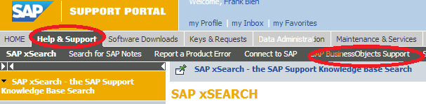

<https://websmp202.sap-ag.de/support-welcome>

[SAP login required]

1. General reference SAP information

<http://www.scribd.com/doc/91155588/Features-of-SAP-Business-Objects-4>

1. Business Objects installation, configuration and running reports

<http://guozspace.wordpress.com/2012/04/28/sap-business-objects-bi-4-0-installation-steps/>

1. Best practices for SAP BOBJ upgrade

<http://wiki.sdn.sap.com/wiki/display/BOBJ/BI+4.0+SP04+Update+-+Best+practices%2C+Known+Issues+and+Possible+Solutions>

1. EMC Greenplum Database, DCA, and DIA Documentation

<http://powerlink.emc.com>

[EMC Power Link login required]

1. Greenplum internal Confluence page on ODBC drivers (32-bit versus 64-bit)

<http://confluence.greenplum.com/display/~mekas1/ODBC+32-bit+and+64-bit+windows+registry+settings>

[Greenplum internal login required]